Peachey, Kevin

From THE FORESTER Sep 2008
On Friday 1st August 2008 six keen second year Forestry students of the Australian National University drove to Yass as part of an afternoon field trip organised by IFA. The focus of the afternoon was learning about the activities of the Murrumbidgee Catchment Management Authority (CMA) in assisting land managers to mitigate salinity on agricultural land through farm forestry.
We visited the Murrumbidgee CMA Office in Yass where ANU alum and Catchment Project Officer Matthew Walker gave an interesting presentation outlining the strategies adopted by the CMA in implementing the scheme. Matthew described the processes and technologies used to overcome the issues involved and also spoke about careers within the NSW CMA network. He took us to a property where we observed the site preparation and planting practises of the scheme in an environment which was conspicuously suffering from effects of salinity.
The excited students who attended the day were Kevin Peachey, Andrew Halliday, Ben Scheele, Olivia Edgar, Alex Slattery and first year student Joel Dawson. The students would like to thank George Dashwood and the IFA for organising the day and a particular thanks to Matthew Walker and CMA for the presentation and property visit and also allowing us to trample through your office, muddy boots and all!
(Andrew Halliday and Alex Slattery
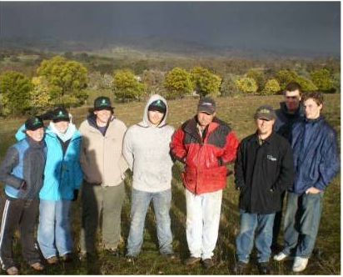

L to R: Alex Slattery, Olivia Edgar, Joel Dawson, Kevin Peachey,
George Dashwood, Matthew Walker, Andrew Halliday, Ben Scheele.

